Project Design Phase
Problem – Solution Fit Template

Date | 20 February 2026
Team ID | LTVIP2026TMIDS66135
Project Name | IntelliSQL: Intelligent SQL Querying with LLMs Using Gemini Pro
Maximum Marks | 2 Marks

Problem – Solution Fit Template:
The Problem-Solution Fit simply means that you have found a problem with your customer and that the solution you have realized for it actually solves the customer’s problem. It helps entrepreneurs, marketers and corporate innovators identify behavioral patterns and recognize what would work and why
Purpose:
- Solving Complex Problems (The State of the Customer):
- The State: Customers feel "frustrated" and "dependent" because they lack SQL coding skills to query the STUDENTS table.
- The Fit: IntelliSQL removes the "technical barrier" by allowing users to interact with databases "effortlessly and intuitively" using natural language.
- Succeeding Faster (Tapping into Existing Behaviours):
- Behaviour: Users are accustomed to asking questions in plain English (like using a search engine) rather than writing code.
- The Fit: By utilizing the Gemini Flash model, the application adopts the user's natural conversational behaviour to generate and execute SQL queries instantly.
- Sharpening Communication (Triggers & Messaging):
- The Triggers: Focus on "Intelligent Query Assistance" and "Syntax Suggestions" as primary hooks for the user.
- The Messaging: Move away from technical jargon; market the tool as a "Revolutionized Database Querying" experience that saves time and increases productivity.
- Increasing Touch-points (Solving Annoyances):
- The Annoyance: The manual, repetitive task of writing queries and the slow turnaround from IT departments.
- The Fit: Providing a professional, Streamlit-based dashboard with real-time results builds trust by solving these "urgent or costly" delays.
- Improving the Existing Situation:
- Current Situation: Data is stored in a data.db file, but it is inaccessible to those without SQL expertise.
- Improvement: The tool bridges this gap, making data exploration and performance optimization available to everyone via an LLM-driven interface.

Template:
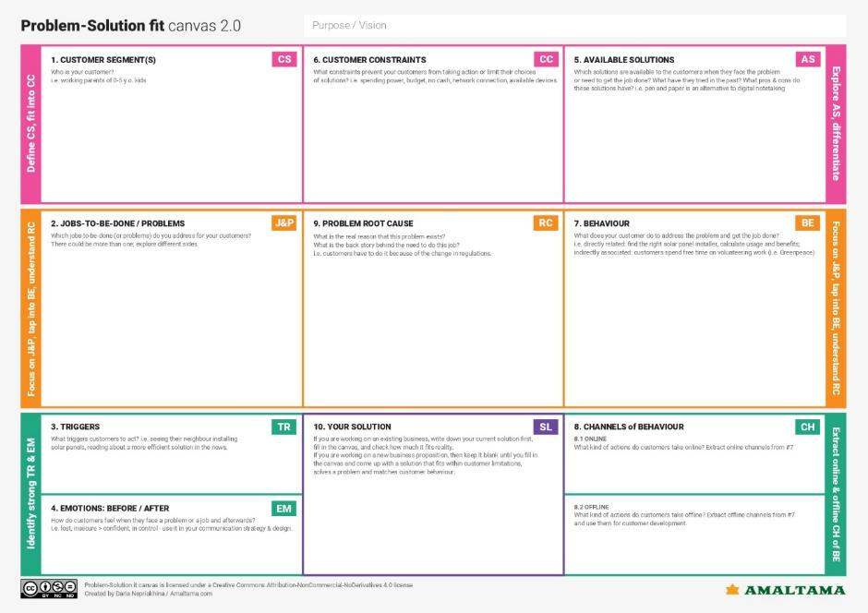
A professional web dashboard where you type a question in English, and an AI (Gemini Flash) writes and runs the SQL for you. It gives you a clean table of results in seconds, making database work "effortless and intuitive".

Getting specific information (like student marks or placement data) out of a database without knowing SQL. Moving past the "technical barrier" that stops non-coders from using databases.
Traditional SQL Tools: Powerful but too hard for beginners (e.g., Oracle SQL Developer).
Manual Requests: Asking the IT team to write a query, which is slow and causes a backlog.

Relational databases were built for machines and coders, not for natural human conversation. There has been a "gap" between human thought and database logic

8.2 Offline: Discussing data needs in staff meetings or via office memos.
8.1 Online: Using web browsers and administrative portals to view student lists.
They search for student info in paper files or simple Excel sheets. They wait for others to help them with data reports.

No Coding Skills: They don't have the time or background to learn SQL syntax. Software Limits: Standard databases don't understand plain English.

An urgent request from a boss for a placement report. Seeing news about how AI (like Gemini) can now do technical tasks for humans.
Before: Feeling frustrated, stuck, and dependent on the IT department. After: Feeling confident, in control, and productive because they can get answers instantly.

Non-technical staff, academic administrators, or data analysts who manage student records but cannot write code. People who are data-reliant but time-constrained.

Summary:
- The Problem: Non-technical staff are "blocked" from accessing student records because they do not know how to write complex SQL code.
- The Behavioural Fit: Instead of forcing users to learn a new programming language, the tool lets them use natural "search engine" behaviour asking questions in plain English.
- The Mechanism: A professional web dashboard uses Gemini Flash to translate human intent into precise SQL commands, which are then cleaned by a logic layer for safety.
- The Outcome: Users get instant, structured data tables, removing the "frequent annoyance" of waiting for IT department assistance.

